About us
The European Compost Network (ECN) is the leading European membership organisation promoting sustainable recycling practices in composting, anaerobic digestion and other biological treatment processes of organic resources. Our purpose is to work with practitioners, researchers, technicians and policy makers to deliver integrated organic waste recycling solutions that generate high quality products for the benefit of the environment and the users of the recycled products. It serves as central resource and network for the organic waste recycling sector in Europe, as well as the emerging bio-based economy.
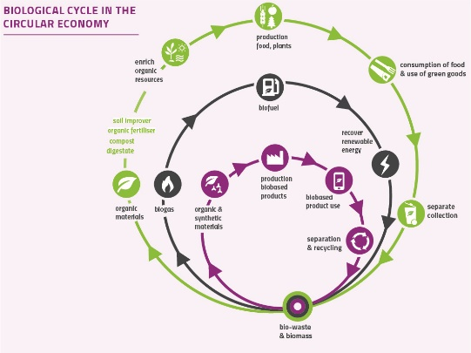
ECN’s Vision
ECN’s vision is living well within the limited resources of the planet respecting the organic cycle.
ECN Objectives
The objective and the main focus of ECN are to promote knowledge about best practices throughout Europe for the establishment of sustainable systems for organic waste management through integration of policies and strategies, technological development and improvement of operations.
ECN Activities
- Providing information of all aspects within the field of activity of the network to policy and decision makers on national and European level.
- Exchange knowledge and experiences in the practice of collection, treatment, recycling, application and marketing of organic wastes including the management of environmental side effects.
- Promoting scientific research and development activities and their co-ordination between the European countries and making available the results, especially the related practical aspects.
- Supporting and establishing systems and tools needed for a qualified recycling of organic resources (such as the European Quality Assurance Scheme for Organic Resources - ECN-QAS)
- Organising conferences, workshops, seminars, education and training courses etc. on an international or regional level and supporting such events organised by other associations active in the range of biological waste.
- Establishing and maintaining relations with other international or national organisations whose activities are related to organic waste management.
About ECN
The European Compost Network is a membership organisation with 65 members from 30 European Countries. Members include all European biowaste organisations and their operating plants, research, policy making, consultants and authorities. Via the member organisations, ECN represents more than 4500 experts and plant operators with more than 45 million tonnes of biological waste treatment capacity.

If you are interested in the work of ECN, please find more information on the ECN website www.compostnetwork.info
Herewith we apply for membership in the European Compost Network ECN e.V.
After confirmation of membership by the ECN Board we will transfer the membership fee of
……….. EURO to the bank account below.

Contact Information
Organisation Name
Department Name
Position
Mr./Ms. - First - Last Name
Street
Postcode City/Town
Country
Telephone
Fax
Email
Web

Major engagement  Scientific  Consulting  Research  Manager/Operator  Education  Policy |  | Membership category (tick only one!)  Biowaste Organisation  Commercial Organisation  Students  Supporting members  Governmental body  Academic institutes  Non-profit Environmental Organisation

Date & Signature

Please let us know few sentences about your company:

Abbrev. | Membership Category | Annual fee 2022⁴⁾
BIOO¹⁾ | Biowaste Organisation
BIOO 0 | ≤ 1.000.000 t Biowaste per year | 1.850 €
BIOO I | ≤ 2.000.000 t Biowaste per year | 4.600 €
BIOO II | ≤ 5.000.000 t Biowaste per year | 9.200 €
BIOO III | ≤ 12.000.000 t Biowaste per year | 14.700 €
BIOO IV | > 12.000.000 t Biowaste per year | 22.100 €
City²⁾ Municipalities | Cities and Municipalities
City S-M | ≤ 250.000 Inhabitants | 1.850 €
City L-XL | ≤1.000.000 Inhabitants | 4.600 €
City XXL | >1.000.000 Inhabitants | 9.200 €
CPO³⁾ | Commercial / Public Organisations
CPO I | 2 to 10 employees | 1.400 €
CPO II | 11 to 25 employees | 2.300 €
CPO III | 26 to 50 employees | 4.600 €
CPO IV | 51 to 100 employees | 9.200 €
CPO V | 101 to 200 employees | 14.700 €
CPO VI | > 200 employees | 22.100 €
STUD | Students | 90 €
Supporting members | Single persons, Academic Institutes, Governmental Body. Non-profit Environmental Organisation outside the bio-waste sector | 500 €

¹⁾ The fee schedule for Biowaste Organisations (BIOO) is based on the current published waste statistics of the EU (€STAT) http://appsso.€stat.ec.€pa.eu/nui/show.do?dataset=env_wasmun&lang=en).
30 to 40 % of municipal solid waste is bio-waste. For the calculation of fees 30 % of municipal waste is taken into account (1.000 t bio-waste/a * 0,001 €). In some cases (like implementing of bio-waste management or separate collection in countries) the fee can be increased in 3 steps (25%, 50%, 75%) in the first years.
Biowaste organisations (BIOO) are defined as organisations supporting the sustainable management of biowaste and the recycling of organic materials. This includes waste management organisations, compost/soil improver organisations and biogas/digestate organisations, as well as quality assurance organisations in the field of organic material recycling. In comparison to the membership type “Bio-waste organisation“ (BIOO) the membership type “Non-profit environmental organisation” (NPEO) does not work specifically in the field of biowaste or organic recycling.

²⁾ The categories for cities and municipalities are categorized based on the OECD EC definition for urban centre. In some cases (like implementing of bio-waste management or separate collection in cities or municipalities) the fee can be increased in 3 steps (25%, 50%, 75%) in the first years.
Source: OECD EC 2012: Cities in €pe – The new OECD_EC Definition. In Regional Focus -A series of short papers on regional research and indicators produced by Directorate-General for Regional and Urban Policy. http://ec.€pa.eu/regional_policy/sources/docgener/focus/2012_01_city.pdf

³⁾ The fees of Commercial / Public Organisations (CPO) are based on the number of employees.

⁴⁾ The fees were agreed at the Annual meeting 2020.

